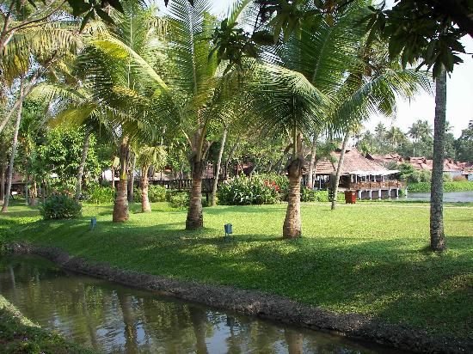

**IMS Landscaping & Landscaping Maintenance**

* The flow of oversight in chain of command goes all the way up to our CEO. He is actively involved in with the coordination of, and oversight of landscaping related activities of our IMS Service teams.
* Under the command of the CEO, the Director of Landscaping oversees the service coordination and scheduling of all maintenance projects, and supervises the employees who actually perform the work.
* Organizationally, our landscaping technicians are compensated at a rate which is $1.25 higher than the median for the Carolinas, and our landscaping supervisors are compensated at a rate which is $1.50 higher than the median for the Carolinas.